You Can Walk, You Can Square Dance
McKinley knows what he's talking about. Square dancing contributes to a more healthy and independent lifestyle, says Lewis Maharam, MD, a sports medicine specialist in NewYork City and President of the Greater New York Regional Chapter American College of Sports Medicine.
"Anything that keeps you active will keep you healthier and feeling younger. In most cases if you can walk, you can square dance, but it's good advice to talk to your doctor before beginning any new exercise regiment, " says Maharam, also director ofthe Suzuki Rock'n'Roll Marathon in San Diego, the Country Music Marathon and the New York City Marathon.
"Any weight-bearing exercise, including square dancing, is a major benefit as one ages, "He says, Weight-bearing exercise improves bone health and thus may help stave off the brittle-bone disease osteoporosis.
"Square dancing also helps you with the feeling of where you are in space and with coordination, and this may reduce falls and chances for fractures," says Maharam. "Regular square dancing may boost endurance, and being able to tolerate longer bouts of moving faster may result in improved cardiac function if trained. Square dancing can be considered a type of cross training, which helps to offset the muscle loss and strength loss typically associated with normal aging."

Live Ten Years Longer!
Square Dancing will add ten years to your life, a surprising new study shows. Dr. Arron Blackburn states, "It's clear that square dancing is the perfect exercise. It combines all the positive aspects of intense physical activity with none of the negative elements."
The study was based on their physical examinations which indicated that both female and male square dancers could expect to live well into their '80's.
The square dance movements raise the heart rate like any good aerobic exercise should. All the quick changes of direction loosen and tone up the muscles - but not so severely as to cause injury. In square dancing, when you're not moving, you're clapping hands or tapping feet, which all contributes to long term fitness.
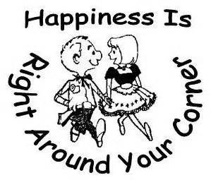
Source: Callerlab Release June, 2001 uploaded June/02
Editor's Note: For information on square or round dancing clubs in your area contact the Association close to you - check out the Federation/Association page

Also endorsed by:
WebMD
http://www.webmd.com/fitness-exercise/dont-be-square-dance
Mayo Clinic Health Newsletter

