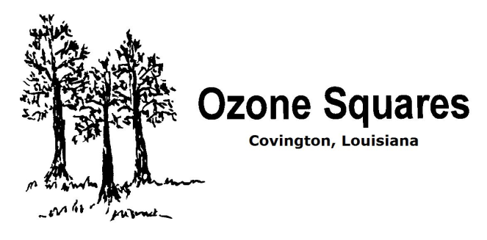
Thank you for joining us for our Open House Event! Please help yourself to the refreshments after the first dance. Here is information you need if you decide to learn to square dance. You are welcome to bring a friend to any future OPEN HOUSE or to the first class.
- Classes begin on March 17th *Thursday
- Classes are held every Thursday at Lyon Elementary School gym – 1615 N. Florida St. Covington, LA (near the St. Tammany Parish Fair Grounds)
- The cost of the class is $12.50 per month per person. (around $3 per class)
- Family discounts are available for families with 2 or more children.
- Casual dress during lessons
- Contact for lessons is Wes or Connie Koon – 985-867-4970 or 985-691-1438 or 985-502-4154
pinekoon@bellsouth.net
Welcome to the World of Square Dancing
where friendship is set to music!

